UNIVERSITY OF ILLINOIS
Urbana-Champaign • Chicago • Springfield

The Board of Trustees
352 Henry Administration Building, MC-350
506 South Wright Street
Urbana, IL 61801
September 10, 2026

NOTICE

On call of the Chair, a meeting of the Audit, Budget, Finance, and Facilities Committee of the Board of Trustees of the University of Illinois will be held on Wednesday, September 16, 2026, beginning at 1:45 p.m., in the Alice Campbell Alumni Center Ballroom, 601 South Lincoln Avenue, Urbana, Illinois. (A copy of the schedule/agenda is attached.)

The meeting will also be webcast live at the following address:
https://www.uis.edu/uislive.

The Board of Trustees meetings are open to the public, pursuant to Illinois state law and the Board’s own procedures. Attendees will not be permitted to knowingly interfere with or impede, through disruptions or other means, the Board’s performance of its institutional duties. Individuals who disrupt the meeting will be asked to leave. If the disruption continues following due notice to depart the meeting space, individuals will be removed from the premises. Individuals who disrupt the Board’s performance of its institutional duties or refuse to leave the meeting may be in violation of state laws, including but not limited to the Illinois Interference with a Public Institution of Education Act.

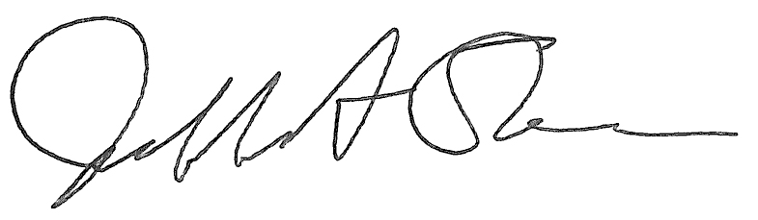
Jeffrey A. Stein Secretary of the Board of Trustees

c: Members of the Board of Trustees
President Killeen
Mr. Engle
University Officers
Members of the Press
Meeting of the Audit, Budget, Finance, and Facilities Committee
of the Board of Trustees of the University of Illinois

University of Illinois Urbana-Champaign
Alice Campbell Alumni Center Ballroom
601 South Lincoln Avenue, Urbana, Illinois

The Audit, Budget, Finance, and Facilities Committee Meeting will be webcast live at the following address:
https://www.uis.edu/uislive

Please be advised that the times for various parts of the meeting are estimates and that the order of business may be adjusted as the meeting progresses.

Wednesday, September 16, 2026
1:45 p.m.* Meeting of the Committee Convenes
- Roll Call
- Opening Remarks by the Chair of the Committee
- Action Item- Approval of Minutes of Meeting of July 15, 2026

1:50 p.m. Review Recommended Board Items for September 17, 2026, Board Meeting
    - Approve Operating Budget for Fiscal Year 2027
    - Approve Project Budget and Construction Contract, Armory Arch Stucco and Curtainwall Replacement, Urbana
    - Approve Project and Design for Carl R. Woese Institute for Genomic Biology Advanced Microscopy & Diagnostics Facility, Urbana
      - Advanced Microscopy and Diagnostics Facility presentation
    - Approve Construction Contract for Swine Research Center Relocation and Modernization, Urbana
    - Approve Design for Demirjian Indoor Golf Facility Expansion and Renovation, Urbana
      - Demirjian Indoor Golf Facility Expansion and Renovation presentation
    - Approve Change to Construction Contract for Japan House Addition – Ogura-Sato Annex, Urbana
    - Approve Project Budget for Drug Discovery and Cancer Research Pavilion, Chicago (Capital Development Board Project)
    - Approve Project Budget for Replace West Side Backup Generators, Chicago
    - Approve Removal of Sunflower Court Student Apartments from the Auxiliary Facilities System, Springfield
    - Approve Master Plan Variance for Building Demolition, Sunflower Court Apartments, Springfield
    - Purchase Recommendations

2:30 p.m. Presentations
- Investment Program Update
- Office of University Audits Fourth Quarter and Annual Report for Fiscal Year Ended June 30, 2026

2:50 p.m. Old Business

New Business
  - Next Meeting- November 11, 2026, 1:45 p.m., Isadore and Sadie Dorin Forum, Rooms D, E, and F, 725 West Roosevelt Road, Chicago

2:55 p.m. Meeting of the Committee Adjourns When Business is Complete

