UNIVERSITY OF ILLINOIS
Urbana-Champaign • Chicago • Springfield

The Board of Trustees
352 Henry Administration Building, MC-350
506 South Wright Street
Urbana, IL 61801

January 11, 2024
NOTICE
On call of the Chair, a meeting of the Academic and Student Affairs Committee of the Board of Trustees of the University of Illinois will be held on Wednesday, January 17, 2024, beginning at 3:30 p.m., in the I Hotel and Conference Center, Heritage Hall, 1901 South First Street, Champaign, Illinois. (A copy of the schedule/agenda is attached.)

The meeting will also be webcast live at the following address: https://www.uis.edu/uislive.

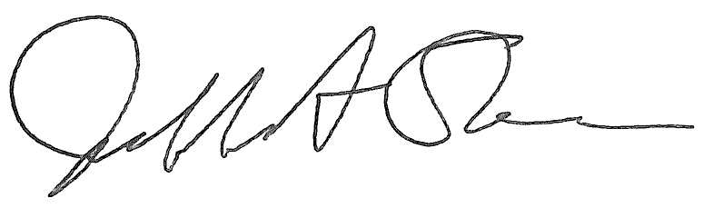
Jeffrey A. Stein Secretary of the Board of Trustees

c: Members of the Board of Trustees
President Killeen
Mr. McKeever
University Officers
Members of the Press

Meeting of the Academic and Student Affairs Committee
of the Board of Trustees of the University of Illinois

University of Illinois Urbana-Champaign
I Hotel and Conference Center, Heritage Hall
1901 South First Street, Champaign, Illinois
The Academic and Student Affairs Committee Meeting will be webcast live at the following address:
https://www.uis.edu/uislive
Please be advised that the times for various parts of the meeting are estimates and that the order of business may be adjusted as the meeting progresses.

Wednesday, January 17, 2024
3:30 p.m.* Meeting of the Committee Convenes
- Roll Call
- Opening Remarks by the Chair of the Committee
- Action Item- Approval of Minutes of Meeting of November 15, 2023

3:35 p.m. Review Recommended Board Items for January 18, 2024, Board Meeting
- Appointments to the Faculty, Administrative/Professional Staff, and Intercollegiate Athletic Staff
- Approve Tuition Rates, Academic Year 2024-2025
- Approve Student Fees for Urbana, Chicago, and Springfield, Academic Year 2024-2025
- Approve Rate Changes for University-Operated Housing Facilities, Urbana, Chicago, and Springfield, Academic Year 2024-2025
- Award Honorary Degrees, Urbana
- Amend the University of Illinois Urbana-Champaign Senate Constitution, Article I, Section 5, and the Bylaws, Urbana
- Amend the University of Illinois Urbana-Champaign Senate Constitution, Article III, Urbana
- Eliminate the Institute for Competitive Manufacturing, The Grainger College of Engineering, Urbana
- Rename the Department of Atmospheric Sciences, College of Liberal Arts and Sciences, Urbana
- Rename the Master of Science in Healthspan Promotion and Rehabilitation, College of Applied Health Sciences and Graduate College, Chicago
- Eliminate the Center for Public Safety and Justice, College of Urban Planning and Public Affairs, Chicago
- Establish the Government Finance Research Center, College of Urban Planning and Public Affairs, Chicago

4:05 p.m. Presentations
- Building Great Inclusive Teams: Not as Easy as 1, 2, 3

4:20 p.m. Old Business

New Business
  - Next Meeting- March 27, 2024, 3:30 p.m., Student Union Ballroom, Room 224, 2251 Richard Wright Drive, Springfield

4:25 p.m. Meeting of the Committee Adjourns When Business is Completed

