UNIVERSITY OF ILLINOIS
Urbana-Champaign • Chicago • Springfield

The Board of Trustees
352 Henry Administration Building, MC-350
506 South Wright Street
Urbana, IL 61801

January 11, 2024

NOTICE

On call of the Chair, a meeting of the Governance, Personnel, and Ethics Committee of the Board of Trustees of the University of Illinois will be held on Wednesday, January 17, 2024, beginning at 1:20 p.m., in the I Hotel and Conference Center, Heritage Hall, 1901 South First Street, Champaign, Illinois. (A copy of the schedule/agenda is attached.)

The meeting will also be webcast live at the following address:
https://www.uis.edu/uislive.

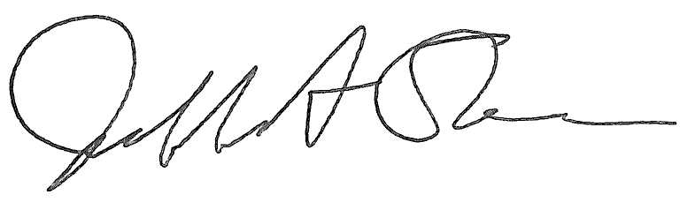
Jeffrey A. Stein
Secretary, Board of Trustees

c. Members of the Board of Trustees
President Killeen
Mr. McKeever
University Officers
Members of the Press
Meeting of the Governance, Personnel, and Ethics Committee
of the Board of Trustees of the University of Illinois

University of Illinois Urbana-Champaign
I Hotel and Conference Center, Heritage Hall
1901 South First Street, Champaign, Illinois

The Governance, Personnel, and Ethics Committee Meeting will be webcast live at the following address:
https://www.uis.edu/uislive

Please be advised that the times for various parts of the meeting are estimates and that the order of business may be adjusted as the meeting progresses.

Wednesday, January 17, 2024
1:20 p.m.* Meeting of the Committee Convenes
- Roll Call
- Opening Remarks by the Chair of the Committee
- Action Item- Approval of Minutes of Meeting of November 15, 2023

1:25 p.m. Review Recommended Board Items for January 18, 2024, Board Meeting
- Appointments to the Faculty, Administrative/Professional Staff, and Intercollegiate Athletic Staff
- Approve Revisions to the University of Illinois System Conflict of Interest Policies
- Appoint University Counsel

1:40 p.m. Presentations
- 2023 Ethics and Compliance Office Annual Report
- Background Check Policy Presentation and State Universities Civil Service System Update
- Legislative Update

2:05 p.m. Old Business

New Business
  - Next Meeting- March 27, 2024, 1:30 p.m., Student Union Ballroom, Room 224, 2251 Richard Wright Drive, Springfield

2:10 p.m. Meeting of the Committee Adjourns When Business is Completed

