UNIVERSITY OF ILLINOIS
Urbana-Champaign • Chicago • Springfield

The Board of Trustees
352 Henry Administration Building, MC-350
506 South Wright Street
Urbana, IL 61801

January 17, 2024

NOTICE – REVISED

Today’s meeting of the UHS Committee is delayed due to inclement weather. The committee will now meet today at 4:00 pm, or 5 mins after the end of ASAC Committee, whichever comes later.

On call of the Chair, a meeting of the University Healthcare System Committee of the Board of Trustees of the University of Illinois will be held on Wednesday, January 17, 2024, beginning at 11:30 a.m. 4:00 p.m., in the I Hotel and Conference Center, Heritage Hall, 1901 South First Street, Champaign, Illinois. (A copy of the schedule/agenda is attached.)

The meeting will also be webcast live at the following address:
https://www.uis.edu/uislive.

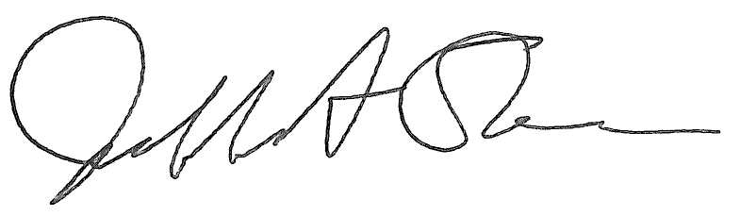
Jeffrey A. Stein
Secretary, Board of Trustees

c. Members of the Board of Trustees
President Killeen
Mr. McKeever
University Officers
Members of the Press

Meeting of the University Healthcare System Committee
of the Board of Trustees of the University of Illinois

University of Illinois Urbana-Champaign
I Hotel and Conference Center, Heritage Hall
1901 South First Street, Champaign, Illinois

The University Healthcare System Committee Meeting will be webcast live at the following address:
https://www.uis.edu/uislive

Please be advised that the times for various parts of the meeting are estimates and that the order of business may be adjusted as the meeting progresses.

Wednesday, January 17, 2024
11:30 a.m. Meeting of the Committee Convenes
4:00 p.m. Roll Call

11:35 a.m. Executive Session
4:05 p.m.
12:35 p.m. Meeting Reconvenes
5:05 p.m. Opening Remarks by the Chair of the Committee
- Action Item- Approval of Minutes of Meeting of November 15, 2023
- Opening Remarks by Dr. Robert Barish, vice chancellor for health affairs, Chicago

12:45 p.m. Review Recommended Board Items for January 18, 2024, Board Meeting
5:15 p.m. Approve Amendments to the Medical Staff Bylaws, University of Illinois1
Hospital and Clinics, Chicago

12:50 p.m. Reports
5:20 p.m. Hospital and Clinics CEO Report, including quality data and report
  - Chief Medical Officer Report

1:05 p.m. Old Business
5:35 p.m.
New Business
  - Next Meeting- March 27, 2024, 12:30 p.m., Student Union Ballroom, Room 224, 2251 Richard Wright Drive, Springfield

1:10 p.m. Meeting of the Committee Adjourns When Business is Completed
5:40 p.m.

Written Reports
  - Hospital Dashboard
  - Annual Quality & Patient Safety Report, University of Illinois Hospital and Clinics

