UNIVERSITY OF ILLINOIS
Urbana-Champaign • Chicago • Springfield

The Board of Trustees
352 Henry Administration Building, MC-350
506 South Wright Street
Urbana, IL 61801
January 16, 2025
NOTICE

On call of the Chair, a meeting of the Academic and Student Affairs Committee of the Board of Trustees of the University of Illinois will be held on Wednesday, January 22, 2025, beginning at 3:30 p.m., in the Isadore and Sadie Dorin Forum, Rooms D, E, and F, 725 West Roosevelt Road, Chicago, Illinois. (A copy of the schedule/agenda is attached.)

The meeting will also be webcast live at the following address: https://www.uis.edu/uislive.

The Board of Trustees meetings are open to the public, pursuant to Illinois state law and the Board’s own procedures. Attendees will not be permitted to knowingly interfere with or impede, through disruptions or other means, the Board’s performance of its institutional duties. Individuals who disrupt the meeting will be asked to leave. If the disruption continues following due notice to depart the meeting space, individuals will be removed from the premises. Individuals who disrupt the Board’s performance of its institutional duties or refuse to leave the meeting may be in violation of state laws, including but not limited to the Illinois Interference with a Public Institution of Education Act.
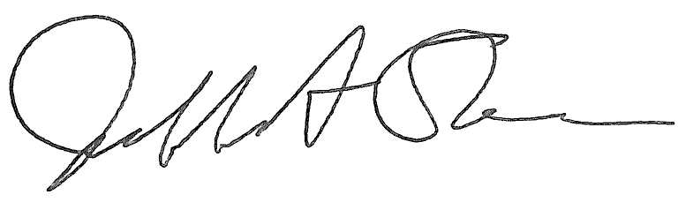
Jeffrey A. Stein Secretary of the Board of Trustees

c: Members of the Board of Trustees
President Killeen
Mr. McKeever
University Officers
Members of the Press

Meeting of the Academic and Student Affairs Committee
of the Board of Trustees of the University of Illinois

University of Illinois Chicago
Isadore and Sadie Dorin Forum, Rooms D, E, and F
725 West Roosevelt Road, Chicago, Illinois
The Academic and Student Affairs Committee Meeting will be webcast live at the following address:
https://www.uis.edu/uislive
Please be advised that the times for various parts of the meeting are estimates and that the order of business may be adjusted as the meeting progresses.

Wednesday, January 22, 2025
3:30 p.m.* Meeting of the Committee Convenes
- Roll Call
- Opening Remarks by the Chair of the Committee
- Action Item- Approval of Minutes of Meeting of November 13, 2024

3:35 p.m. Review Recommended Board Items for January 23, 2025, Board Meeting
- Appointments to the Faculty, Administrative/Professional Staff, and Intercollegiate Athletic Staff
- Approve Tuition Rates, Academic Year 2025-2026
- Approve Student Fees for Urbana, Chicago, and Springfield, Academic Year 2025-2026
- Approve Rate Changes for University-Operated Housing Facilities, Urbana, Chicago, and Springfield, Academic Year 2025-2026
- Award Honorary Degree, Urbana
- Establish the Bachelor of Science in Nuclear, Plasma, and Radiological Engineering + Data Science, The Grainger College of Engineering, Urbana
- Eliminate the Bachelor of Science in Athletic Training, College of Applied Health Sciences, Urbana
- Establish the Center for Research and Innovation in Technology-Enhanced Learning, College of Education, Urbana
- Rename the Center for Women and Gender in Global Perspectives, College of Liberal Arts and Sciences, Urbana
- Extend Term, Provost and Vice Chancellor for Academic Affairs, Chicago
- Award Honorary Degrees, Springfield
- Establish the Center for Lincoln Studies as a Permanent Center, Springfield

4:05 p.m. Presentation
- Future Proofed: The Role of the Library in Academic Exploration

4:20 p.m. Old Business

New Business
  - Next Meeting- March 19, 2025, 3:30 p.m., Student Union Ballroom, Room 224, 2251 Richard Wright Drive, Springfield

4:25 p.m. Meeting of the Committee Adjourns When Business is Completed

The UIC Dorin Forum does not permit graphic boards or posters inside the facility. All bags will be subject to inspection.

