UNIVERSITY OF ILLINOIS
Urbana-Champaign • Chicago • Springfield

The Board of Trustees
352 Henry Administration Building, MC-350
506 South Wright Street
Urbana, IL 61801
July 10, 2025

NOTICE

On call of the Chair, a meeting of the Governance, Personnel, and Ethics Committee of the Board of Trustees of the University of Illinois will be held on Wednesday, July 16, 2025, beginning at 1:30 p.m., in the Isadore and Sadie Dorin Forum, Rooms D, E, and F, 725 West Roosevelt Road, Chicago, Illinois. (A copy of the schedule/agenda is attached.)

The meeting will also be webcast live at the following address:
https://www.uis.edu/uislive.

The Board of Trustees meetings are open to the public, pursuant to Illinois state law and the Board’s own procedures. Attendees will not be permitted to knowingly interfere with or impede, through disruptions or other means, the Board’s performance of its institutional duties. Individuals who disrupt the meeting will be asked to leave. If the disruption continues following due notice to depart the meeting space, individuals will be removed from the premises. Individuals who disrupt the Board’s performance of its institutional duties or refuse to leave the meeting may be in violation of state laws, including but not limited to the Illinois Interference with a Public Institution of Education Act.

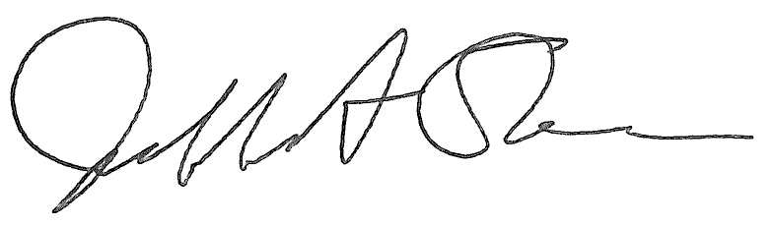
Jeffrey A. Stein
Secretary, Board of Trustees

c. Members of the Board of Trustees
President Killeen
Mr. McKeever
University Officers
Members of the Press
Meeting of the Governance, Personnel, and Ethics Committee
of the Board of Trustees of the University of Illinois

University of Illinois Chicago
Isadore and Sadie Dorin Forum, Rooms D, E, and F
725 West Roosevelt Road, Chicago, Illinois

The Governance, Personnel, and Ethics Committee Meeting will be webcast live at the following address:
https://www.uis.edu/uislive

Please be advised that the times for various parts of the meeting are estimates and that the order of business may be adjusted as the meeting progresses.

Wednesday, July 16, 2025
1:30 p.m. Meeting of the Committee Convenes
- Roll Call
- Opening Remarks by the Chair of the Committee
- Action Item- Approval of Minutes of Meeting of May 21, 2025

1:35 p.m. Review Recommended Board Items for July 17, 2025, Board Meeting
- Appointments to the Faculty, Administrative/Professional Staff, and Intercollegiate Athletic Staff
- Appoint Member to the University of Illinois Research Park, LLC, Board of Managers, Urbana
- Appoint Vice Chancellor for Finance, Urbana
- Appoint Vice Chancellor for Finance and Administration, Springfield

1:45 p.m. Presentations
- Enterprise Risk Management Annual Report
- Legislative Update

2:05 p.m. Old Business

New Business
  - Next Meeting- September 17, 2025, 1:30 p.m., I Hotel and Conference Center, Heritage Hall, 1901 South First Street, Champaign

2:10 p.m. Meeting of the Committee Adjourns When Business is Completed

The UIC Dorin Forum does not permit graphic boards or posters inside the facility. All bags will be subject to inspection.

