UNIVERSITY OF ILLINOIS
Urbana-Champaign • Chicago • Springfield

The Board of Trustees
352 Henry Administration Building, MC-350
506 South Wright Street
Urbana, IL 61801

July 13, 2023

NOTICE

On call of the Chair, a meeting of the Audit, Budget, Finance, and Facilities Committee of the Board of Trustees of the University of Illinois will be held on Wednesday, July 19, 2023, beginning at 2:15 p.m., in the Isadore and Sadie Dorin Forum, Rooms D, E, and F, 725 West Roosevelt Road, Chicago, Illinois. (A copy of the schedule/agenda is attached.)

The meeting will also be webcast live at the following address:
https://www.uis.edu/uislive.

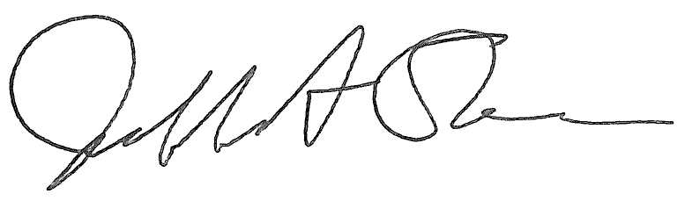
Jeffrey A. Stein Secretary of the Board of Trustees

c: Members of the Board of Trustees
President Killeen
Mr. McKeever
University Officers
Members of the Press

Meeting of the Audit, Budget, Finance, and Facilities Committee
of the Board of Trustees of the University of Illinois

University of Illinois Chicago
Isadore and Sadie Dorin Forum, Rooms D, E, and F
725 West Roosevelt Road, Chicago, Illinois

The Audit, Budget, Finance, and Facilities Committee Meeting will be webcast live at the following address:
https://www.uis.edu/uislive

Please be advised that the times for various parts of the meeting are estimates and that the order of business may be adjusted as the meeting progresses.

Wednesday, July 19, 2023
2:15 p.m.* Meeting of the Committee Convenes
- Roll Call
- Opening Remarks by the Chair of the Committee
- Action Item- Approval of Minutes of Meeting of May 17, 2023

2:20 p.m. Review Recommended Board Items for July 20, 2023, Board Meeting
- Approve Revision to the University’s Liability Self-Insurance Plan
- Approve Development Agreement for the University of Illinois Research Park, Urbana
- Approve Design for Small Animal Clinic Oncology Center Addition, Veterinary Teaching Hospital, Urbana
- Amend Professional Services Consultant Contract for Illinois Autonomous and Connected Track Facility, Urbana
    - Purchase Recommendations

2:40 p.m. Presentations
- Small Animal Clinic Oncology Center Addition Design Presentation, Veterinary Teaching Hospital
- RSM FY2023 Audit Plan Presentation
- University Audits Two-Year Internal Audit Plan for Fiscal Years 2024-2025

3:15 p.m. Old Business

New Business
  - Next Meeting- September 20, 2023, 2:15 p.m., Student Dining and Residential Programs Building, Multi-Purpose Room 2025 A, B, and C, 301 East Gregory Drive, Champaign

3:20 p.m. Meeting of the Committee Adjourns When Business is Complete

