UNIVERSITY OF ILLINOIS
Urbana-Champaign • Chicago • Springfield

The Board of Trustees
352 Henry Administration Building, MC-350
506 South Wright Street
Urbana, IL 61801

July 13, 2023
NOTICE
On call of the Chair, a meeting of the Academic and Student Affairs Committee of the Board of Trustees of the University of Illinois will be held on Wednesday, July 19, 2023, beginning at 3:30 p.m., in the Isadore and Sadie Dorin Forum, Rooms D, E, and F, 725 West Roosevelt Road, Chicago, Illinois. (A copy of the schedule/agenda is attached.)

The meeting will also be webcast live at the following address:
https://www.uis.edu/uislive.

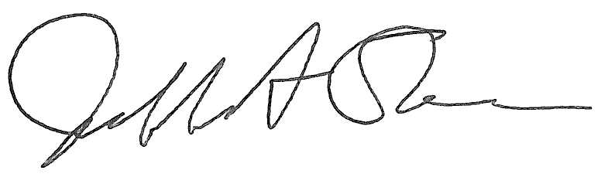
Jeffrey A. Stein Secretary of the Board of Trustees

c: Members of the Board of Trustees
President Killeen
Mr. McKeever
University Officers
Members of the Press

Meeting of the Academic and Student Affairs Committee
of the Board of Trustees of the University of Illinois

University of Illinois Chicago
Isadore and Sadie Dorin Forum, Rooms D, E, and F
725 West Roosevelt Road, Chicago, Illinois
The Academic and Student Affairs Committee Meeting will be webcast live at the following address:
https://www.uis.edu/uislive
Please be advised that the times for various parts of the meeting are estimates and that the order of business may be adjusted as the meeting progresses.

Wednesday, July 19, 2023
3:30 p.m.* Meeting of the Committee Convenes
- Roll Call
- Opening Remarks by the Chair of the Committee
- Action Item- Approval of Minutes of Meeting of May 17, 2023

3:35 p.m. Review Recommended Board Items for July 20, 2023, Board Meeting
- Appointments to the Faculty, Administrative/Professional Staff, and Intercollegiate Athletic Staff
- Promotions in Academic Rank and Change in Tenure, 2023-2024
- Approve Pilot Tuition Program for St. Charles and St. Louis Counties in Missouri and Scott County in Iowa, Springfield
- Approve Revocation of Doctor of Philosophy Degree, Urbana
- Appoint Dean, School of Social Work, Urbana
- Appoint Interim Dean, College of Law, Urbana
- Extend Term, Dean, College of Media, Urbana
- Extend Term, Dean, College of Fine and Applied Arts, Urbana
- Establish the Center for Culturally Responsive Evaluation and Assessment as a Permanent Center, College of Education, Urbana
- Establish the Center for Global Studies as a Permanent Center, College of Liberal Arts and Sciences, Urbana
- Establish the Center for South Asian and Middle Eastern Studies as a Permanent Center, College of Liberal Arts and Sciences, Urbana
- Establish the Illinois Global Institute as a Permanent Institute, College of Liberal Arts and Sciences, Urbana
- Establish the Women and Gender in Global Perspectives Program as a Permanent Center, College of Liberal Arts and Sciences, Urbana
- Eliminate the Master of Arts in Teaching of Social Studies, College of Liberal Arts and Sciences and the Graduate College, Urbana
- Appoint Provost and Vice Chancellor for Academic Affairs, Chicago
- Appoint Dean, College of Business Administration, Chicago
- Eliminate the Bachelor of Arts in Liberal Arts and Sciences, Major in Classical Languages and Literatures, College of Liberal Arts and Sciences, Chicago
- Establish the Bachelor of Music in Music Education, College of Architecture, Design, and the Arts, Chicago
- Eliminate University of Illinois College of Medicine at Urbana-Champaign, University of Illinois College of Medicine, Chicago
- Establish the Center for Population Health, Health Equity, Outcomes and Informatics Research (C4Health Research), University of Illinois College of Medicine Peoria, Chicago
- Establish the Doctor of Philosophy in Health Professions Education, University of Illinois College of Medicine and Graduate College
- Establish the Institute for Healthcare Delivery Design, Office of the Vice Chancellor for Health Affairs, Chicago
- Appoint Vice Chancellor for Academic Affairs and Provost, Springfield
- Appoint Vice Chancellor for Student Affairs, Springfield
- Appoint Dean, College of Liberal Arts and Social Sciences, Springfield
- Appoint Interim Dean, College of Health, Science and Technology, Springfield

4:15 p.m. Presentations
- Generative AI Update

4:25 p.m. Old Business

New Business
  - Next Meeting- September 20, 2023, 3:30 p.m., Student Dining and Residential Programs Building, Multi-Purpose Room 2025 A, B, and C, 301 East Gregory Drive, Champaign

4:30 p.m. Meeting of the Committee Adjourns When Business is Completed

