UNIVERSITY OF ILLINOIS
Urbana-Champaign • Chicago • Springfield

The Board of Trustees
352 Henry Administration Building, MC-350
506 South Wright Street
Urbana, IL 61801

July 13, 2023

NOTICE

On call of the Chair, a meeting of the Governance, Personnel, and Ethics Committee of the Board of Trustees of the University of Illinois will be held on Wednesday, July 19, 2023, beginning at 1:30 p.m., in the Isadore and Sadie Dorin Forum, Rooms D, E, and F, 725 West Roosevelt Road, Chicago, Illinois. (A copy of the schedule/agenda is attached.)

The meeting will also be webcast live at the following address:
https://www.uis.edu/uislive.

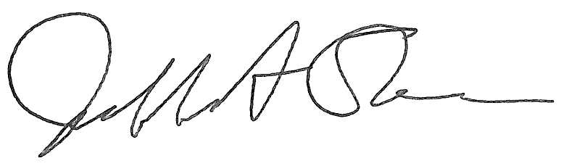
Jeffrey A. Stein
Secretary, Board of Trustees

c. Members of the Board of Trustees
President Killeen
Mr. McKeever
University Officers
Members of the Press
Meeting of the Governance, Personnel, and Ethics Committee
of the Board of Trustees of the University of Illinois

University of Illinois Chicago
Isadore and Sadie Dorin Forum, Rooms D, E, and F
725 West Roosevelt Road, Chicago, Illinois

The Governance, Personnel, and Ethics Committee Meeting will be webcast live at the following address:
https://www.uis.edu/uislive

Please be advised that the times for various parts of the meeting are estimates and that the order of business may be adjusted as the meeting progresses.

Wednesday, July 19, 2023
1:30 p.m.* Meeting of the Committee Convenes
- Roll Call
- Opening Remarks by the Chair of the Committee
- Action Item- Approval of Minutes of Meeting of May 17, 2023

1:35 p.m. Review Recommended Board Items for July 20, 2023, Board Meeting
- Appointments to the Faculty, Administrative/Professional Staff, and Intercollegiate Athletic Staff
- Amend the University of Illinois Statutes
- Revisions to the University of Illinois System Policy on Background Checks
- Appoint Members to the Athletic Board, Urbana
- Appoint members and renew terms to the University of Illinois Research Park, LLC, Board of Managers
- Appoint Interim Vice Chancellor for Finance and Administration, Springfield
- Approve Minutes of the Board of Trustees as the Sole Member of Prairieland Energy, Inc., Meeting
- Appoint Directors, Prairieland Energy, Inc.

1:45 p.m. Presentations
- Enterprise Risk Management Annual Report and Digital Risk Update
- Legislative Update

2:00 p.m. Old Business

New Business
  - Next Meeting- September 20, 2023, 1:30 p.m., Student Dining and Residential Programs Building, Multi-Purpose Room 2025 A, B, and C, 301 East Gregory Drive, Champaign

2:05 p.m. Meeting of the Committee Adjourns When Business is Completed

