UNIVERSITY OF ILLINOIS
Urbana-Champaign • Chicago • Springfield

The Board of Trustees
352 Henry Administration Building, MC-350
506 South Wright Street
Urbana, IL 61801
March 13, 2025
NOTICE

On call of the Chair, a meeting of the Academic and Student Affairs Committee of the Board of Trustees of the University of Illinois will be held on Wednesday, March 19, 2025, beginning at 3:15 p.m., in the Student Union Ballroom, Room 224, 2251 Richard Wright Drive, Springfield, Illinois. (A copy of the schedule/agenda is attached.)

The meeting will also be webcast live at the following address: https://www.uis.edu/uislive.

The Board of Trustees meetings are open to the public, pursuant to Illinois state law and the Board’s own procedures. Attendees will not be permitted to knowingly interfere with or impede, through disruptions or other means, the Board’s performance of its institutional duties. Individuals who disrupt the meeting will be asked to leave. If the disruption continues following due notice to depart the meeting space, individuals will be removed from the premises. Individuals who disrupt the Board’s performance of its institutional duties or refuse to leave the meeting may be in violation of state laws, including but not limited to the Illinois Interference with a Public Institution of Education Act.

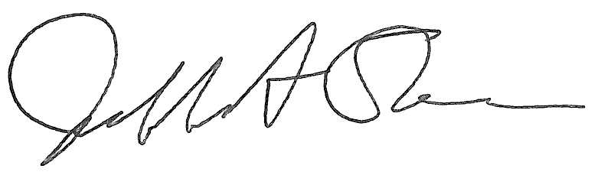
Jeffrey A. Stein Secretary of the Board of Trustees

c: Members of the Board of Trustees
President Killeen
Mr. McKeever
University Officers
Members of the Press

Meeting of the Academic and Student Affairs Committee
of the Board of Trustees of the University of Illinois

University of Illinois Springfield
Student Union Ballroom, Room 224,
2251 Richard Wright Drive, Springfield, Illinois
The Academic and Student Affairs Committee Meeting will be webcast live at the following address:
https://www.uis.edu/uislive
Please be advised that the times for various parts of the meeting are estimates and that the order of business may be adjusted as the meeting progresses.

Wednesday, March 19, 2025
3:15 p.m.* Meeting of the Committee Convenes
- Roll Call
- Opening Remarks by the Chair of the Committee
- Action Item- Approval of Minutes of Meeting of January 22, 2025

3:20 p.m. Review Recommended Board Items for March 20, 2025, Board Meeting
- Appointments to the Faculty, Administrative/Professional Staff, and Intercollegiate Athletic Staff
- Approve Sabbatical Leaves of Absence, Urbana, Chicago, Springfield, 2025-2026
- Approve Student Health Insurance Rate for Urbana, Chicago, Springfield, Academic Year 2025-2026
- Approve Application Fee Increases for Urbana, Chicago, and Springfield
- Approve Expansion of Pilot Tuition Program for Lake, Porter, and LaPorte Counties in Indiana, Muscatine and Clinton Counties in Iowa, and Marion County in Missouri, Springfield
- Delegate Authority to Establish and Approve Student-Athlete Name, Image, Likeness Policies
- Establish the Bachelor of Arts in Media, College of Media, Urbana
- Establish the Department of Oncology, Carle Illinois College of Medicine, Urbana
- Establish the Department of Surgery and Digestive Health, Carle Illinois College of Medicine, Urbana
- Establish the Department of Cardiovascular Medicine and Surgery, Carle Illinois College of Medicine, Urbana
- Establish the Department of Neurology and Neurosurgery, Carle Illinois College of Medicine, Urbana
- Eliminate the Master of Science in Sustainable Urban Management, College of Fine and Applied Arts and the Graduate College, Urbana
- Establish the Department of Population Oral Health, College of Dentistry, Chicago
- Establish the Master of Science in Analytics and Artificial Intelligence in Business, College of Business Administration and the Graduate College, Chicago
- Eliminate the Bachelor of Science in Economics, College of Business Administration

3:55 p.m. Presentation
- Growing U of I’s Leaders

4:05 p.m. Old Business

New Business
  - Next Meeting- May 21, 2025, 2:30 p.m., I Hotel and Conference Center, Heritage Hall, 1901 South First Street, Champaign

4:10 p.m. Meeting of the Committee Adjourns When Business is Completed

