UNIVERSITY OF ILLINOIS
Urbana-Champaign • Chicago • Springfield

The Board of Trustees
352 Henry Administration Building, MC-350
506 South Wright Street
Urbana, IL 61801

March 21, 2024
NOTICE
On call of the Chair, a meeting of the Academic and Student Affairs Committee of the Board of Trustees of the University of Illinois will be held on Wednesday, March 27, 2024, beginning at 3:20 p.m., in the Student Union Ballroom, Room 224, 2251 Richard Wright Drive, Springfield, Illinois. (A copy of the schedule/agenda is attached.)

The meeting will also be webcast live at the following address: https://www.uis.edu/uislive.

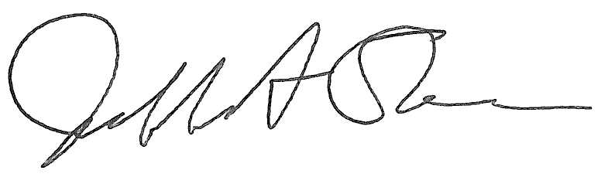
Jeffrey A. Stein Secretary of the Board of Trustees

c: Members of the Board of Trustees
President Killeen
Mr. McKeever
University Officers
Members of the Press

Meeting of the Academic and Student Affairs Committee
of the Board of Trustees of the University of Illinois

University of Illinois Springfield
Student Union Ballroom, Room 224,
2251 Richard Wright Drive, Springfield, Illinois
The Academic and Student Affairs Committee Meeting will be webcast live at the following address:
https://www.uis.edu/uislive
Please be advised that the times for various parts of the meeting are estimates and that the order of business may be adjusted as the meeting progresses.

Wednesday, March 27, 2024
3:20 p.m.* Meeting of the Committee Convenes
- Roll Call
- Opening Remarks by the Chair of the Committee
- Action Item- Approval of Minutes of Meeting of January 17, 2024

3:25 p.m. Review Recommended Board Items for March 28, 2024, Board Meeting
- Appointments to the Faculty, Administrative/Professional Staff, and Intercollegiate Athletic Staff
- Approve Sabbatical Leaves of Absence, 2024-2025
- Approve Student Health Insurance Rates for University of Illinois Urbana-Champaign, Academic Year 2024-2025
- Appoint Interim Vice Chancellor for Diversity, Equity, and Engagement, Chicago
- Appoint Dean, College of Dentistry, Chicago
- Appoint Interim Dean, College of Public Affairs and Education, Springfield
- Rename the Department of English and Modern Languages, College of Liberal Arts and Social Sciences, Springfield
- Appoint Fellows to the Center for Advanced Study, Academic Year 2024-2025, Urbana
- Appoint Associates to the Center for Advanced Study, Academic Year 2024-2025, Urbana
- Establish the Master of Science in Game Development, School of Information Sciences and the Graduate College, Urbana
- Appoint Faculty Fellows to the Institute for the Humanities, Academic Year 2024-2025, College of Liberal Arts and Sciences, Chicago
- Establish the Bachelor of Arts in Liberal Arts and Sciences, Major in Linguistics, College of Liberal Arts and Sciences, Chicago
- Establish the Bill and Julie Kellner Center for Neurogenomics, Behavior, and Society, Carl R. Woese Institute for Genomic Biology, Urbana
- Amend the University of Illinois Urbana-Champaign Senate Constitution, Urbana
- Award Honorary Degree, Urbana
- Award Honorary Degree, Springfield

3:55 p.m. Presentations
- Research Integrity
- Aspirations for Consilience at UIS

4:20 p.m. Old Business

New Business
  - Next Meeting- May 15, 2024, 3:30 p.m., I Hotel and Conference Center, Heritage Hall, 1901 South First Street, Champaign

4:25 p.m. Meeting of the Committee Adjourns When Business is Completed

