UNIVERSITY OF ILLINOIS
Urbana-Champaign • Chicago • Springfield

The Board of Trustees
352 Henry Administration Building, MC-350
506 South Wright Street
Urbana, IL 61801

May 11, 2023
NOTICE
On call of the Chair, a meeting of the Academic and Student Affairs Committee of the Board of Trustees of the University of Illinois will be held on Wednesday, May 17, 2023, beginning at 3:30 p.m., in the I Hotel and Conference Center, Heritage Hall, 1901 South First Street, Champaign, Illinois. (A copy of the schedule/agenda is attached.)

The meeting will also be webcast live at the following address:
https://www.uis.edu/uislive.

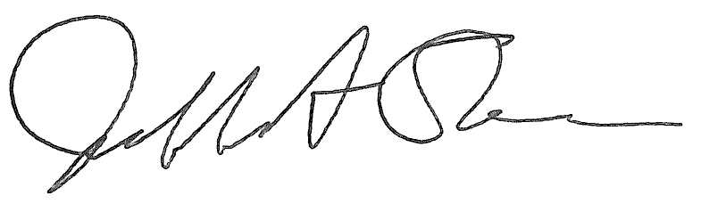
Jeffrey A. Stein Secretary of the Board of Trustees

c: Members of the Board of Trustees
President Killeen
Mr. McKeever
University Officers
Members of the Press

Meeting of the Academic and Student Affairs Committee
of the Board of Trustees of the University of Illinois

University of Illinois Urbana-Champaign
I Hotel and Conference Center, Heritage Hall
1901 South First Street, Champaign, Illinois
The Academic and Student Affairs Committee Meeting will be webcast live at the following address:
https://www.uis.edu/uislive
Please be advised that the times for various parts of the meeting are estimates and that the order of business may be adjusted as the meeting progresses.

Wednesday, May 17, 2023
3:30 p.m.* Meeting of the Committee Convenes
- Roll Call
- Opening Remarks by the Chair of the Committee
- Action Item- Approval of Minutes of Meeting of March 29, 2023

3:35 p.m. Review Recommended Board Items for May 18, 2023, Board Meeting
- Appointments to the Faculty, Administrative/Professional Staff, and Intercollegiate Athletic Staff
- Appoint Interim Chancellor, University of Illinois Chicago, Chicago
- Approve Tuition Rates for Online Master of Science in Architectural Studies, Structures Concentration, Urbana, and Online Master of Public Administration, Chicago
- Appoint Vice Chancellor for Academic Affairs and Provost, Urbana
- Amend the University of Illinois Urbana-Champaign Senate Constitution, Urbana
- Appoint Dean, College of Agricultural, Consumer and Environmental Sciences, Urbana
- Rename the Department of Kinesiology and Community Health, College of Applied Health Sciences, Urbana
- Appoint Dean, College of Liberal Arts and Sciences, Chicago
- Establish the Department of Latin American and Latino Studies, College of Liberal Arts and Sciences and Graduate College, Chicago
- Appoint Interim Vice Chancellor for Academic Affairs and Provost, Springfield
- Rename and reorganize the Bachelor of Arts in Global Studies, College of Public Affairs and Education, Springfield

4:25 p.m. Old Business

New Business
  - Next Meeting- July 19, 2023, 3:30 p.m., Isadore and Sadie Dorin Forum, Rooms D, E, and F, 725 West Roosevelt Road, Chicago

4:30 p.m. Meeting of the Committee Adjourns When Business is Completed

