UNIVERSITY OF ILLINOIS
Urbana-Champaign • Chicago • Springfield

The Board of Trustees
352 Henry Administration Building, MC-350
506 South Wright Street
Urbana, IL 61801

May 11, 2023

NOTICE

On call of the Chair, a meeting of the University Healthcare System Committee of the Board of Trustees of the University of Illinois will be held on Wednesday, May 17, 2023, beginning at 12:30 p.m., in the I Hotel and Conference Center, Heritage Hall, 1901 South First Street, Champaign, Illinois. (A copy of the schedule/agenda is attached.)

The meeting will also be webcast live at the following address:
https://www.uis.edu/uislive.

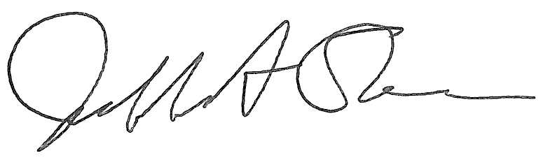
Jeffrey A. Stein
Secretary, Board of Trustees

c. Members of the Board of Trustees
President Killeen
Mr. McKeever
University Officers
Members of the Press

Meeting of the University Healthcare System Committee
of the Board of Trustees of the University of Illinois

University of Illinois Urbana-Champaign
I Hotel and Conference Center, Heritage Hall
1901 South First Street, Champaign, Illinois

The University Healthcare System Committee Meeting will be webcast live at the following address:
https://www.uis.edu/uislive

Please be advised that the times for various parts of the meeting are estimates and that the order of business may be adjusted as the meeting progresses.

Wednesday, May 17, 2023
12:30 p.m. Meeting of the Committee Convenes
- Roll Call
- Opening Remarks by the Chair of the Committee
- Action Item- Approval of Minutes of Meeting of March 29, 2023
- Opening Remarks by Dr. Robert Barish, Vice Chancellor for Health Affairs, Chicago

12:40 p.m. Review Recommended Board Items for May 18, 2023, Board Meeting
- Approve the University of Illinois Community Assessment of Needs Report and Implementation Plan, University of Illinois Hospital and Health Sciences System, Chicago
- Amend Appointment of Interim Chief Executive Officer, University of Illinois Hospital and Clinics, Chicago

12:50 p.m. Reports
  - Hospital and Clinics CEO Report, including quality data
  - Compliance Update

1:00 p.m. Old Business

New Business
  - Next Meeting- July 19, 2023, 12:30 p.m., Isadore and Sadie Dorin Forum, Rooms D, E, and F, 725 West Roosevelt Road, Chicago

1:05 p.m. Executive Session

1:15 p.m. Meeting of the Committee Reconvenes
  - Action Item- Disclose Certain Minutes of Executive Session Pursuant to the Open Meetings Act

1:20 p.m. Meeting of the Committee Adjourns When Business is Completed

Written Reports
  - Hospital Dashboard

