UNIVERSITY OF ILLINOIS
Urbana-Champaign • Chicago • Springfield

The Board of Trustees
352 Henry Administration Building, MC-350
506 South Wright Street
Urbana, IL 61801
May 15, 2025

NOTICE

On call of the Chair, a meeting of the Audit, Budget, Finance, and Facilities Committee of the Board of Trustees of the University of Illinois will be held on Wednesday, May 21, 2025, beginning at 1:15 p.m., in the I Hotel and Conference Center, Heritage Hall, 1901 South First Street, Champaign, Illinois. (A copy of the schedule/agenda is attached.)

The meeting will also be webcast live at the following address:
https://www.uis.edu/uislive.

The Board of Trustees meetings are open to the public, pursuant to Illinois state law and the Board’s own procedures. Attendees will not be permitted to knowingly interfere with or impede, through disruptions or other means, the Board’s performance of its institutional duties. Individuals who disrupt the meeting will be asked to leave. If the disruption continues following due notice to depart the meeting space, individuals will be removed from the premises. Individuals who disrupt the Board’s performance of its institutional duties or refuse to leave the meeting may be in violation of state laws, including but not limited to the Illinois Interference with a Public Institution of Education Act.

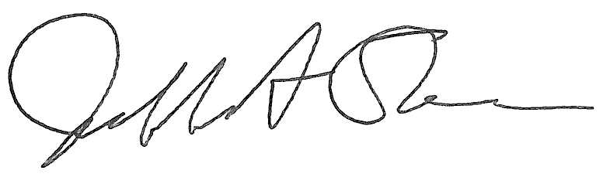
Jeffrey A. Stein Secretary of the Board of Trustees

c: Members of the Board of Trustees
President Killeen
Mr. McKeever
University Officers
Members of the Press
Meeting of the Audit, Budget, Finance, and Facilities Committee
of the Board of Trustees of the University of Illinois

University of Illinois Urbana-Champaign
I Hotel and Conference Center, Heritage Hall
1901 South First Street, Champaign, Illinois

The Audit, Budget, Finance, and Facilities Committee Meeting will be webcast live at the following address:
https://www.uis.edu/uislive

Please be advised that the times for various parts of the meeting are estimates and that the order of business may be adjusted as the meeting progresses.

Wednesday, May 21, 2025
1:15 p.m.* Meeting of the Committee Convenes
- Roll Call
- Opening Remarks by the Chair of the Committee
- Action Item- Approval of Minutes of Meeting of March 19, 2025

1:20 p.m. Review of Recommended Board Items for May 22, 2025, Board Meeting
    - Approve Preliminary Operating Budget for Fiscal Year 2026
    - Reappoint Chief Internal Auditor
    - Approve Project Budget for Nurse Anesthesia Program (NAP) Simulation Lab, Chicago
    - Approve Project Budget for Innovation Center Expansion, Chicago (Capital Development Board Project)
    - Approve Project Budget for Computer Design Research and Learning Center, Chicago (Capital Development Board Project)
    - Approve Project Budget for Library Commons, Springfield (Capital Development Board Project)
    - Purchase Recommendations

2:00 p.m. Presentation
- Fiscal Year 2024 External Audit Update
- Summary of Internal Audit Activity Through Third Quarter Ended March 31, 2025

2:10 p.m. Old Business

New Business
  - Next Meeting- July 16, 2025, 2:15 p.m., Isadore and Sadie Dorin Forum, Rooms D, E, and F, 725 West Roosevelt Road, Chicago

2:15 p.m. Executive Session

2:20 p.m. Meeting of the Committee Reconvenes
  - Action Item- Disclose Certain Minutes of Executive Session Pursuant to the Open Meetings Act

2:25 p.m. Meeting of the Committee Adjourns When Business is Complete

Per hotel management, the I Hotel and Conference Center does not permit signs inside the facility. All bags will be subject to inspection.

