UNIVERSITY OF ILLINOIS
Urbana-Champaign • Chicago • Springfield

The Board of Trustees
352 Henry Administration Building, MC-350
506 South Wright Street
Urbana, IL 61801
November 8, 2024

NOTICE

On call of the Chair, a meeting of the University Healthcare System Committee of the Board of Trustees of the University of Illinois will be held on Wednesday, November 13, 2024, beginning at 12:30 p.m., in the Isadore and Sadie Dorin Forum, Rooms D, E, and F, 725 West Roosevelt Road, Chicago, Illinois. (A copy of the schedule/agenda is attached.)

The meeting will also be webcast live at the following address:
https://www.uis.edu/uislive.

The Board of Trustees meetings are open to the public, pursuant to Illinois state law and the Board’s own procedures. Attendees will not be permitted to knowingly interfere with or impede, through disruptions or other means, the Board’s performance of its institutional duties. Individuals who disrupt the meeting will be asked to leave. If the disruption continues following due notice to depart the meeting space, individuals will be removed from the premises. Individuals who disrupt the Board’s performance of its institutional duties or refuse to leave the meeting may be in violation of state laws, including but not limited to the Illinois Interference with a Public Institution of Education Act.

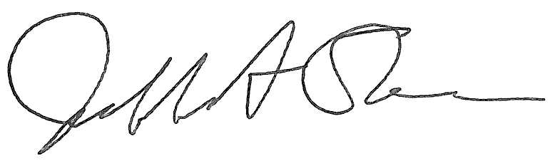
Jeffrey A. Stein
Secretary, Board of Trustees

c. Members of the Board of Trustees
President Killeen
Mr. McKeever
University Officers
Members of the Press

Meeting of the University Healthcare System Committee
of the Board of Trustees of the University of Illinois

University of Illinois Chicago
Isadore and Sadie Dorin Forum, Rooms D, E, and F
725 West Roosevelt Road, Chicago, Illinois

The University Healthcare System Committee Meeting will be webcast live at the following address:
https://www.uis.edu/uislive

Please be advised that the times for various parts of the meeting are estimates and that the order of business may be adjusted as the meeting progresses.

Wednesday, November 13, 2024
12:30 p.m. Meeting of the Committee Convenes
- Roll Call

12:35 p.m. Executive Session

12:55 p.m. Meeting Reconvenes
- Opening Remarks by the Chair of the Committee
- Action Item- Approval of Minutes of Meeting of September 18, 2024
- Action Item- Disclose Certain Minutes of Executive Session Pursuant to the Open Meetings Act
- Opening Remarks by Dr. Robert Barish, vice chancellor for health affairs, Chicago

1:05 p.m. Reports
  - Hospital and Clinics CEO Report, including quality metrics
  - Graduate Medical Education Report

1:20 p.m. Old Business

New Business
  - Next Meeting- January 22, 2025, 12:30 p.m., Isadore and Sadie Dorin Forum, Rooms D, E, and F, 725 West Roosevelt Road, Chicago

1:25 p.m. Meeting of the Committee Adjourns When Business is Completed

Written Reports
  - Hospital Dashboard

The UIC Dorin Forum does not permit graphic boards or posters inside the facility. All bags will be subject to inspection.

