UNIVERSITY OF ILLINOIS
Urbana-Champaign • Chicago • Springfield

The Board of Trustees
352 Henry Administration Building, MC-350
506 South Wright Street
Urbana, IL 61801

November 9, 2023

NOTICE

On call of the Chair, a meeting of the Audit, Budget, Finance, and Facilities Committee of the Board of Trustees of the University of Illinois will be held on Wednesday, November 15, 2023, beginning at 2:15 p.m., in the Isadore and Sadie Dorin Forum, Rooms D, E, and F, 725 West Roosevelt Road, Chicago, Illinois. (A copy of the schedule/agenda is attached.)

The meeting will also be webcast live at the following address:
https://www.uis.edu/uislive.

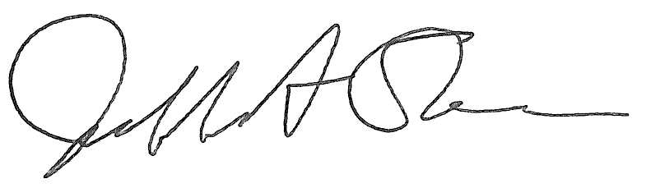
Jeffrey A. Stein Secretary of the Board of Trustees

c: Members of the Board of Trustees
President Killeen
Mr. McKeever
University Officers
Members of the Press

Meeting of the Audit, Budget, Finance, and Facilities Committee
of the Board of Trustees of the University of Illinois

University of Illinois Chicago
Isadore and Sadie Dorin Forum, Rooms D, E, and F
725 West Roosevelt Road, Chicago, Illinois

The Audit, Budget, Finance, and Facilities Committee Meeting will be webcast live at the following address:
https://www.uis.edu/uislive

Please be advised that the times for various parts of the meeting are estimates and that the order of business may be adjusted as the meeting progresses.

Wednesday, November 15, 2023
2:15 p.m.* Meeting of the Committee Convenes
- Roll Call
- Opening Remarks by the Chair of the Committee
- Action Item- Approval of Minutes of Meeting of September 20, 2023

2:20 p.m. Review Recommended Board Items for November 16, 2023, Board Meeting
    - Approve Requests for Operating and Capital Appropriations, Fiscal Year 2025
    - Rename the Graduate School of Library and Information Sciences Building, Urbana
    - Delegate Authority to Comptroller to Approve Lease Extensions for UIC College of Nursing Space Located at 616 E. Green St. and 627 S. Wright St., Champaign, Illinois
    - Award Construction Contract, Krannert Center for the Performing Arts -Accessibility and Elevator Upgrades, Urbana
    - Approve Project Budget and Award Construction Contracts, Noyes Laboratory Rooms 219 and 250, Renovations, Urbana
    - Approve Project Budget and Award Construction Contract for Planning, Sustainability, and Project Management (PSPM) Consolidation to Taylor Street Building, Chicago
    - Approve Project Budget and Award Construction Contract for Renovate Sterile Processing and Material Management, University of Illinois Hospital, Chicago
    - Purchase Recommendations

3:00 p.m. Presentations
- Summary of Internal Audit Activity Through First Quarter Ended September 30, 2023

3:10 p.m. Old Business

New Business
  - Next Meeting- January 17, 2024, 2:15 p.m., Isadore and Sadie Dorin Forum, Rooms D, E, and F, 725 West Roosevelt Road, Chicago

3:15 p.m. Executive Session

3:20 p.m. Meeting of the Committee Reconvenes
  - Action Item- Disclose Certain Minutes of Executive Session Pursuant to the Open Meetings Act

3:25 p.m. Meeting of the Committee Adjourns When Business is Complete

