UNIVERSITY OF ILLINOIS
Urbana-Champaign • Chicago • Springfield

The Board of Trustees
352 Henry Administration Building, MC-350
506 South Wright Street
Urbana, IL 61801

September 15, 2023

NOTICE

On call of the Chair, a meeting of the Audit, Budget, Finance, and Facilities Committee of the Board of Trustees of the University of Illinois will be held on Wednesday, September 20, 2023, beginning at 2:15 p.m., in the Student Dining and Residential Programs Building, Multi-Purpose Room 2025 B and C, 301 East Gregory Drive, Champaign, Illinois. (A copy of the schedule/agenda is attached.)

The meeting will also be webcast live at the following address:
https://www.uis.edu/uislive.

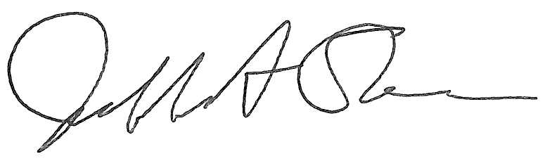
Jeffrey A. Stein Secretary of the Board of Trustees

c: Members of the Board of Trustees
President Killeen
Mr. McKeever
University Officers
Members of the Press

Meeting of the Audit, Budget, Finance, and Facilities Committee
of the Board of Trustees of the University of Illinois

University of Illinois Urbana-Champaign
Student Dining and Residential Programs Building,
Multi-Purpose Room 2025 B and C
301 East Gregory Drive, Champaign, Illinois

The Audit, Budget, Finance, and Facilities Committee Meeting will be webcast live at the following address:
https://www.uis.edu/uislive

Please be advised that the times for various parts of the meeting are estimates and that the order of business may be adjusted as the meeting progresses.

Wednesday, September 20, 2023
2:15 p.m.* Meeting of the Committee Convenes
- Roll Call
- Opening Remarks by the Chair of the Committee
- Action Item- Approval of Minutes of Meeting of July 19, 2023

2:20 p.m. Review Recommended Board Items for September 21, 2023, Board Meeting
    - Approve Operating Budget for Fiscal Year 2024
    - Approve Fiscal Year 2024 Services and Management Agreement for the University of Illinois Foundation
    - Delegate Authority to the Comptroller to Initiate a Public-Private Partnership Pre-Development Process and to Enter into Related Agreements to Construct the Grenshaw Street Parking Structure, Chicago
    - Approve Construction Manager Contract for Renovate Taft Hall, Chicago
    - Approve Design for Innovation Center Expansion, Chicago
    - Employ Architect/Engineer for Renovation of the UIS Innovation Center, Springfield
    - Purchase Recommendations

3:00 p.m. Presentations
- Investment Program Update
- Innovation Center Expansion, University of Illinois Chicago
- Fourth Quarter and Annual Report for Fiscal Year Ended June 30, 2023

3:20 p.m. Old Business

New Business
  - Next Meeting- November 15, 2023, 2:15 p.m., Isadore and Sadie Dorin Forum, Rooms D, E, and F, 725 West Roosevelt Road, Chicago

3:25 p.m. Meeting of the Committee Adjourns When Business is Complete

