UNIVERSITY OF ILLINOIS
Urbana-Champaign • Chicago • Springfield

The Board of Trustees
352 Henry Administration Building, MC-350
506 South Wright Street
Urbana, IL 61801

September 15, 2023

NOTICE

On call of the Chair, a meeting of the University Healthcare System Committee of the Board of Trustees of the University of Illinois will be held on Wednesday, September 20, 2023, beginning at 12:30 p.m., in the Student Dining and Residential Programs Building, Multi-Purpose Room 2025 B and C, 301 East Gregory Drive, Champaign, Illinois. (A copy of the schedule/agenda is attached.)

The meeting will also be webcast live at the following address:
https://www.uis.edu/uislive.

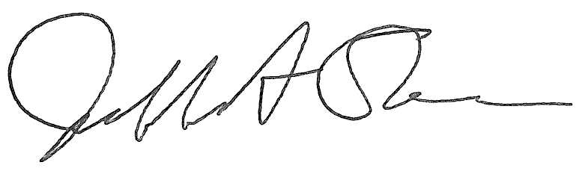
Jeffrey A. Stein
Secretary, Board of Trustees

c. Members of the Board of Trustees
President Killeen
Mr. McKeever
University Officers
Members of the Press

Meeting of the University Healthcare System Committee
of the Board of Trustees of the University of Illinois

University of Illinois Urbana-Champaign
Student Dining and Residential Programs Building,
Multi-Purpose Room 2025 B and C
301 East Gregory Drive, Champaign, Illinois

The University Healthcare System Committee Meeting will be webcast live at the following address:
https://www.uis.edu/uislive

Please be advised that the times for various parts of the meeting are estimates and that the order of business may be adjusted as the meeting progresses.

Wednesday, September 20, 2023
12:30 p.m. Meeting of the Committee Convenes
- Roll Call
- Opening Remarks by the Chair of the Committee
- Action Item- Approval of Minutes of Meeting of July 19, 2023
- Opening Remarks by Dr. Robert Barish, vice chancellor for health affairs, Chicago

12:35 p.m. Reports
  - Hospital and Clinics CEO Report, including financial update, quality metrics, and nursing metrics

1:05 p.m. Presentation
    - Introducing the Office of Medicaid Innovation

1:15 p.m. Old Business

New Business
  - Next Meeting- November 15, 2023, 12:30 p.m., Isadore and Sadie Dorin Forum, Rooms D, E, and F, 725 West Roosevelt Road, Chicago

1:20 p.m. Executive Session

1:25 p.m. Meeting of the Committee Reconvenes to Adjourn When Business is Completed
Written Reports
  - Hospital Dashboard

